ACTIVITY 04 - Tutorial on astronomical simulation software to investigate celestial objects and astronomical phenomena.
Year Level: Years 3 to 12 (typically 8 to 18 years of age).

Background: This tutorial is to learn the basics of the program Stellarium version 0.11.0 which is a free software program that is available from the internet at the following site : http://www.stellarium.org/ Once downloaded, this tutorial will provide a basic insight into some of the many possibilities of this sky simulation program. It shows a realistic sky in 3D, just like what you see with the naked eye, binoculars or a telescope.
Aim: To become familiar with and be able to use the features of the Stellarium program to investigate different objects in the sky and investigate astronomical events. Completing this activity first will enable students to complete Activity 07 to investigate the total solar eclipse and Activity 21 to investigate the annular eclipse of 2013. THIS ACTIVITY IS TO BE DONE BEFORE ACTIVITY 07.
Shape of the Australian Curriculum: Science strands on focus areas.

Content descriptors: Year 3, 5, 7 and 10
Science Understanding | Science as a Human Endeavour | Science Inquiry Skills
Yr 3  Earth’s rotation on its axis causes regular changes, including night and day (ACSSU048) | Yr 3  Science involves making predictions and describing patterns and relationships (ACSHE050) | Yr3  With guidance, identify questions in familiar contexts that can be investigated scientifically and predict what might happen based on prior knowledge (ACSIS053)
Yr 5  The Earth is part of a system of planets orbiting around a star (the Sun) (ACSSU078)  Yr 7  Predictable phenomena on Earth, including seasons and eclipses, are caused by the relative positions of the Sun, Earth and the Moon (ACSSU115) | Yr 5  Science involves testing predictions by gathering data and using evidence to develop explanations of events and phenomena (ACSHE081)  Important contributions to the advancement of science have been made by people from a range of cultures (ACSHE082)  Yr 7  Scientific knowledge changes as new evidence becomes available, and some scientific discoveries have significantly changed people’s understanding of the world (ACSHE119) | Yr 5  With guidance, pose questions to clarify practical problems or inform a scientific investigation, and predict what the findings of an investigation might be (ACSIS231)  Yr 7  Identify questions and problems that can be investigated scientifically and make predictions based on scientific knowledge (ACSIS124)  Collaboratively and individually plan and conduct a range of investigation types, including fieldwork and experiments, ensuring safety and ethical guidelines are followed (ACSIS125)
Yr 10  The universe contains features including galaxies, stars and solar systems and the Big Bang theory can be used to explain the origin the universe (ACSSU188) | Yr 10  Scientific understanding, including models and theories, are contestable and are refined over time through a process of review by the scientific community (ACSHE191)  Advances in scientific understanding often rely on developments in technology and technological advances are often linked to scientific discoveries (ACSHE192)  People can use scientific knowledge to evaluate whether they should accept claims, explanations or predictions (ACSHE194) | Yr 10  Plan, select and use appropriate investigation methods, including field work and laboratory experimentation, to collect reliable data; assess risk and address ethical issues associated with these methods (ACSIS199)  Select and use appropriate equipment, including digital technologies, to systematically and accurately collect and record data (ACSIS200)  Use knowledge of scientific concepts to draw conclusions that are consistent with evidence (ACSIS204)  Communicate scientific ideas and information for a particular purpose, including constructing evidence-based arguments and using appropriate scientific language, conventions and representations (ACSIS208)

Copyright:
This document has been produced by members of the Astronomical Association of Queensland (AAQ) and the Science Teachers Association of Queensland (STAQ). AAQ and STAQ retain copyright of the document. The material in the document may be freely reproduced provided that it is used for non-commercial purposes and the source is acknowledged. Address any request for use of the material for commercial purposes to eclipse@aaq.org.au

.

STELLARIUM TUTORIAL

The following Tutorial will help you learn the basics of using Stellarium. Stellarium is a safe interactive astronomy software program that can be downloaded free from: http://www.stellarium.org/

Once downloaded, double-click the Stellarium icon on your computer. If you move your computer mouse to the lower left hand edge or bottom edge of the screen a transparent pop up menu appears which will allow you to control your actions. The screen for the program should look like the following including the pop up menu. This screen shot below will be referred to for various actions throughout this tutorial.

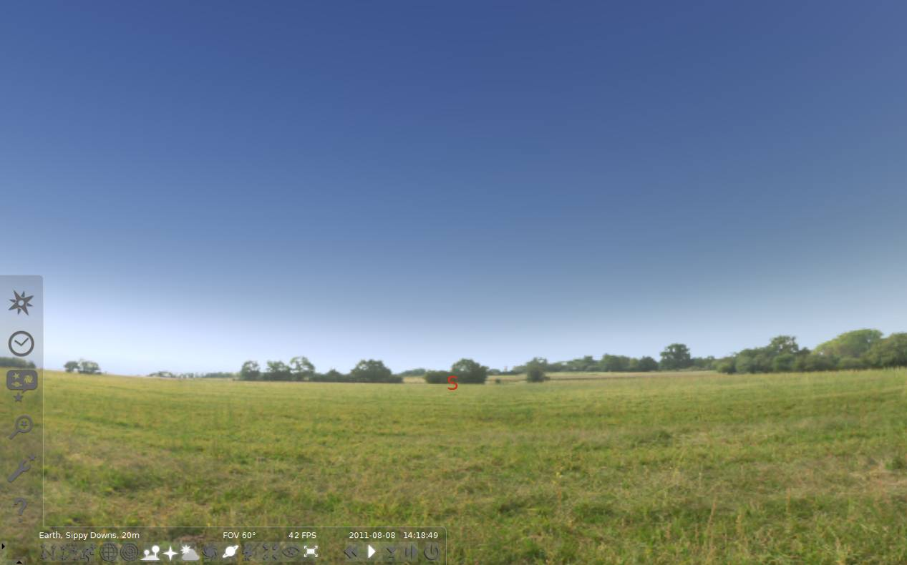
*F
*G
*DD
*E
*C
*B
*AA

- Open the location window by clicking on the compass rose on the left pop up tool bar (*A). Type CAIRNS in the box with the magnifying glass and then click on Cairns, Australia as it comes up on the list. A red arrow should point to Cairns on the map of Australia. Close this LOCATION box by clicking on the X.
- To see the sky at night we need to change the time. Click the Date/time window (*B) and scroll the hours forward to 20:00:07. Set the date to 2011 04 28 as shown below.
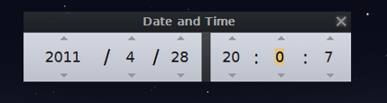
Close this Date and Time pop up by clicking on the X.
- Go to the Sky and Viewing options window menu to the left (*C). Check that show planets is ticked. Go to Markings Tab and click on the box for Ecliptic Line. This is a red line that shows the plane of the solar system. The planets, Sun and the Moon (and the constellations of the zodiac) all lie on this plane, or close to, this line (the ecliptic). Close the View pop up menu by clicking the top right box in the menu.
To see the ecliptic line you will have to click and drag the Horizon from left to right until you see the EAST (E). The ecliptic line is between (E) and the star Antares. Clicking and dragging will change the location of the sky you are looking at.
- To turn on the constellations, their lines, labels and their art, click on the 3 buttons on the bottom pop up row (*D). You can click on them again to turn them off.
- With the EAST (E) approximately in the centre of the screen click and drag the sky from top to bottom until Saturn comes into view. Click on Saturn with the mouse arrow and you will notice a red rotating cross around the object. In the top left hand side of the screen information about Saturn will be displayed. Press Space to centre it and zoom in. Zooming in or out of the sky can be done with the scroll wheel. Alternatively you can zoom in using the Page Up Key or out using the Page Down Key on the keyboard.
- Select the moon Tethys, centre it and then zoom in. Once finished, zoom back to normal sky view with the horizon visible. If the horizon is curved in shape you can click on the horizon near the EAST (E) and drag the horizon towards the top of the screen to straighten it out and then zoom in until it looks as it did before.
- You can search for other objects by pressing the Magnifying Glass button on the left (*E) and typing in the object’s name (or ID number). Type in M104 and click the magnifying glass button. This is the SOMBRERO GALAXY. Zoom in on this object. This is how it would look through a telescope. Once finished looking zoom back to the normal sky view with the horizon. This makes it easier to see new objects as you search for them.
- Now try M83, remembering to click on the magnifying glass and zoom in and out.
USE THE INTERNET TO FIND OUT ABOUT THIS OBJECT SUCH AS DISTANCE AND OTHER FEATURES.
- Try M4 AND RESEARCH THIS OBJECT’S CHARACTERISTICS.
- Some objects at this time of the year will appear below the horizon. You can still go to these objects but will need to turn off the horizon. Go to M20 and it appears below the horizon. To turn off the ground use the Ground button on the bottom pop up as marked (*F). Once turned off you can zoom into and out of this object. Once finished return to the normal sky view (To do this quickly go to Saturn and turn the ground back on).
- SELECTING YOUR EXACT LOCATION : Open the location window by clicking on the compass rose on the left pop up tool bar (*A). You have set the current location for Cairns but you can customise this program for your exact location. Using another program, such as GOOGLE EARTH, find the location of your house in terms of degrees minutes and seconds for both Latitude and Longitude. You should have written something that is in the form for example (23° 34’ 12.00” S for Latitude and 142° 34’ 34.12” E for Longitude). The symbols (°) refers to degrees, (‘) minutes and (“) for seconds.
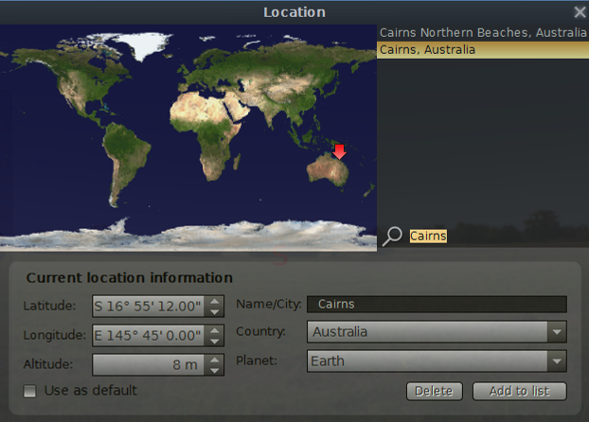
To adjust STELLARIUM to your location use the arrows up/down in the Latitude box. Adjust to suit your latitude in terms of degrees. To change both minutes and seconds you will have to click in the minute’s section and then use the arrow keys to adjust this section or highlight the relevant section you wish to adjust and just type in the desired value. Repeat this process for the seconds. For any location in Australia you do not need to adjust the letter S as all Australian latitudes are south of the equator. For Longitude all locations in Australia will have the letter E for east of Greenwich.
Adjust the Longitude setting as required and you can also highlight the Altitude value and put in your own height above sea level.
To name your location highlight the town Cairns in the Name/City box and type in your location. Leave country and planet as is but these can be changed for later use. Click on the Add to list box and you will see your location appear next to the map of the Earth. By clicking on Use as default Stellarium will always open at your place.
You can try to set the location to your town by typing in the name beside the magnifying glass. If your town comes up in the list above you can click on it. Some of the larger cities and towns in Queensland will be listed.
- SEE WHAT WILL BE IN THE SKY TONIGHT : When you have set the location to your home, set the date to today’s date and the time to 7PM (19 hours 0 minutes 0 seconds). Orientate the sky to be looking east (click and drag the horizon left or right). Zoom out so that you can see both the N and S (for north and south directions).
Now speed up time. To learn how to do that READ THE NEXT TWO PARAGRAPHS IN THEIR ENTIRITY BEFORE CARRYING OUT ANY ACTIONS.
If you want to go forward in time (speed time up) you can press the letter L and this will make time go faster. You can return to normal speed (time) by pressing the K key once. Press the letter L twice and time will speed up more, three times even faster. You can return to normal speed (time) by pressing the K key once at any time.
To go backwards in time press the J key once, twice or three times depending on the speed required. Make sure you press the k key to return to normal time. Do not press the L or J keys too many times as it will speed up the display too much and you may have to reset the date and time to get back to where you were.
Now speed up time by pressing the L key three times and watch as the stars and planets rise in the sky throughout the night. If you see a planet rise, return to normal time (press the K key) and write down the time that the planet rises. The date and time is displayed at the bottom of the screen (right hand end of the pop up menu). Find out what time each of the planets rise. What time does the Moon rise and what time will the Sun rise tomorrow morning? You may have to wait until after the Sun rises to see the Moon rise.
Set back to normal speed and reset the time to 8 PM tonight (20 hours 0 minutes 0 seconds). Then look around the sky – click and drag from left to right and up and down to see what is in the sky tonight at 8 PM. Are there any planets? Will the Moon be in the sky? Where are the bright stars. Can you find the Southern Cross. Go out tonight and look for some of the objects you have found.
- WATCH THE SKY TURN : Leave the time set at 8 PM and the location set to your home or town. Click and drag the sky to face south (with the S about in the centre of the screen. Press the L key three times and watch what happens to the stars. Can you see the point that remains stationary and the rest of the sky rotating around that point? Can you work out why it does that?
- If you wish to exit this program you need to click on the bottom right hand end of the pop up as shown on the screen shot marked (*G).

