ACTIVITY 10 – Eclipse Pinhole Projection
Year Level: Years 3 to 12 (typically 8 to 18 years of age).
Background: The Queensland Government has provided advice on how to observe the eclipse safely. One of the recommended methods is to use Pinhole Projection. This lesson plan describes how to construct a pinhole projector starting with a simple basic projector that every student can easily make; then describing alternative constructions designed to make the projector more effective including a cardboard box pinhole projector. The Pinhole projector method will allow students to effectively and safely observe the Moon passing across the face of the Sun during the eclipse. This can be used not only to observe the partial eclipse that occurs before and after the total eclipse in North Queensland but can also be used to observe the deep partial eclipse that will occur right across Queensland at the same time. The pinhole projector has the disadvantage of not being able to show any surface features on the Sun such as sunspots or the transit of a planet. Activity 11 describes Binocular or telescope projection which can show sunspots. The clear advantage of using the projection method is that no one is looking at the Sun. You only look at the projected image of the Sun which is completely safe. This is called indirect viewing.
Aim: To learn how to construct a pinhole projector that will allow safe indirect viewing of a solar eclipse.
References:
- Section 5 “How to Observe the Sun Safely” of the AAQ/STAQ teacher booklet.
- PowerPoint presentation PP05 “Observe the Eclipse Safely”
Safety Warning: Students should be reminded to never look directly at the bright surface of the Sun without suitable eye protection as permanent eye damage may result. This applies at any time and especially during the partial phases of a solar eclipse.
Risk Assessment: It is strongly recommended that for any activity involving the Sun teachers conduct a risk assessment before undertaking such an activity. This should include review of the Queensland Government’s safe viewing advice at:
http://www.fairtrading.qld.gov.au/safe-viewing-of-astronomical-events.htm
Shape of the Australian Curriculum: Science strands on focus areas.

Content descriptors: Year 3, 5, 7 and 10
Science Understanding | Science as a Human Endeavour | Science Inquiry Skills
Yr 3  Earth’s rotation on its axis causes regular changes, including night and day (ACSSU048) |  | Yr 3  Represent and communicate ideas and findings in a variety of ways such as diagrams, physical representations and simple reports (ACSIS060)
Yr 5  The Earth is part of a system of planets orbiting around a star (the Sun) (ACSSU078) | Yr 5  Science involves testing predictions by gathering data and using evidence to develop explanations of events and phenomena (ACSHE081)  Important contributions to the advancement of science have been made by people from a range of cultures (ACSHE082) | Yr 5  Communicate ideas, explanations and processes in a variety of ways, including multi-modal texts (ACSIS093)
Yr 7  Predictable phenomena on Earth, including seasons and eclipses, are caused by the relative positions of the Sun, Earth and the Moon (ACSSU115) | Yr 7  Scientific knowledge changes as new evidence becomes available, and some scientific discoveries have significantly changed people’s understanding of the world (ACSHE119) | Yr 7  Communicate ideas, findings and solutions to problems using scientific language and representations using digital technologies as appropriate (ACSIS133)
Yr 10  The universe contains features including galaxies, stars and solar systems and the Big Bang theory can be used to explain the origin the universe (ACSSU188) | Yr 10  Advances in scientific understanding often rely on developments in technology and technological advances are often linked to scientific discoveries (ACSHE192) | Yr 10  Communicate scientific ideas and information for a particular purpose, including constructing evidence-based arguments and using appropriate scientific language, conventions and representations (ACSIS208)

Copyright:
This document has been produced by members of the Astronomical Association of Queensland (AAQ) and the Science Teachers Association of Queensland (STAQ). AAQ and STAQ retain copyright of the document. The material in the document may be freely reproduced provided that it is used for non-commercial purposes and the source is acknowledged. Address any request for use of the material for commercial purposes to eclipse@aaq.org.au.

Simple Pinhole Projector
The basic requirements for a pinhole projector are a small hole to shine the light from the Sun through and a screen on which to project the image.
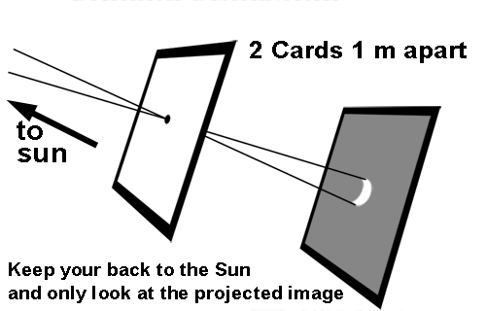
The simplest way to arrange this is to use two pieces of card. Make a small hole in one of the cards. Hold the cards parallel and about a metre apart and faced towards the Sun with the card with the hole in it closest to the Sun. Project an image of the Sun through the hole in the card onto the other card. If there is no eclipse, the Sun will be seen as a disk. During the partial phase of a solar eclipse the crescent shape of the Sun can easily be seen.
It is important to stand facing away from the Sun and only look at the projected image. Do NOT look at the Sun through the hole in the card.
Experiment with different sized holes. A larger hole will make the image brighter, but it will have fuzzy edges. A smaller hole will make the edges of the image clearer but the image will be fainter. You can also experiment with increasing the distance between the two cards. A reasonable compromise can usually be made with a hole about 1 or 2mm in diameter and about one metre between the two cards.
An improvement can be made by making the edges of the hole sharper. To do this cut a larger hole in the front card. Tape a piece of aluminium foil over the hole and use a pin to make a clean hole in the foil. This also makes it easier to experiment with different sized holes as several different sized holes can be made in the foil to see the effect of each.
Safe Observing:
It is very important that you never look directly at the bright surface of the Sun without suitable eye protection as you may cause permanent damage your eyes. This applies at any time and especially during the partial phases of a solar eclipse. Pinhole projection allows you to safely observe the eclipse. It is called indirect viewing and is safe because you are not looking at the Sun; you look at a projected image of the Sun which is quite safe. When using the projector, stand with your back to the Sun and look only at the projected image of the Sun. No one must look at the Sun through the hole in the card.
Cardboard Box Pinhole Projector
When you make a simple pinhole projector with two cards as described above, the image of the Sun on the second card is not very bright and it can be difficult to see it in the bright outdoors. One way to improve this is to enclose the projector in a tube or box.
The following description is taken (with permission) from the following website: http://www.exploratorium.edu/eclipse/how.html . It is an excellent source of information about solar related topics. It is written by Ron Hipschman. © Exploratorium, www.exploratorium.edu
Materials required are a long cardboard box (one to two metre long), a piece of aluminium foil, a pin, and a sheet of white paper.
The length of the box is important. The longer the box, the bigger the pinhole image will be. To find the size of the image, multiply the length of the box by the number 0.00873. For a box that is 1 meter long, the image will be 0.00873 meters (or 8.77 mm) in diameter. If you want to round things off, the size of the image in millimetres is about 1/100th the length of the box.
METHOD
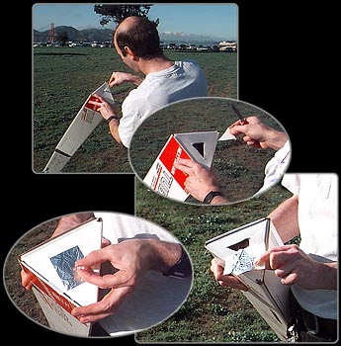
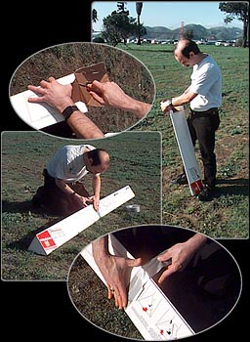
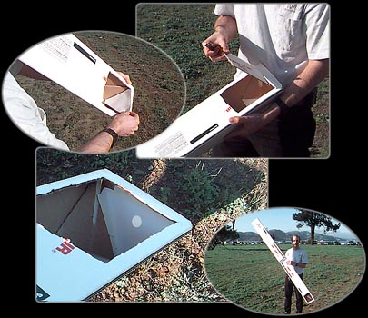
1) Find or make a long box or tube.
If you can't find a long box or tube, you can tape together two or more boxes to make a longer one. In the illustrations below, we found that taping together two triangular shipping tubes works well. Of course, if you do this, you must cut out the cardboard at the ends of the tube in the middle!
1.
2) Cut a hole in the centre of one end of the box.
2.
3) Tape a piece of foil over the hole.
6.
5.
4.
3.
4) Poke a small hole in the foil with a pin
5) Cut a viewing hole in the side of the box.
6) Put a piece of white paper inside the end of the box near the viewing portal.
7.
6.
5.
7) Point the end of the box with the pinhole at the Sun so that you see a round image on the paper at the other end. If you are having trouble pointing, look at the shadow of the box on the ground. Move the box so that the shadow looks like the end of the box (so the sides of the box are not casting a shadow). The round spot of light you see on the paper is a pinhole image of the Sun.
Do not look through the pinhole at the Sun! Look only at the image on the paper.
Postal Tube Pinhole Projector
Postal tubes also work well. Use a similar procedure as with the cardboard box. Place aluminium foil over one end of the tube and hold it in place with a rubber band. Put a small hole in the foil. At the other end cut a hole in the side of the tube (somewhat like an archway). Put the tube end piece in the other end of the tube but place a piece of white paper over the end piece inside the tube. Orientate the tube with the pinhole end facing the Sun. Observe the image of the Sun falling onto the piece of paper by looking through the hole in the side of the tube.
There are more detailed instructions for a tube type projector on the Smithsonian Libraries website: http://www.sil.si.edu/exhibitions/chasing-venus/teachers/lessonplan9.htm
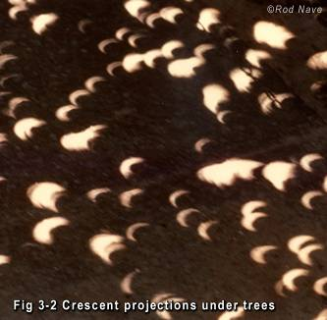
Pinhole Projection Under Trees
During the partial phases of an eclipse, images of the crescent shape of the Sun can be seen projected under trees on the ground or onto adjacent walls, as the gaps between leaves act as pinhole projectors. This is often particularly noticeable with palm trees when palm fronds cross and create multiple pinholes. If the Sun is at a low angle such as with the eclipse in North Queensland 2012, the shadow of the tree and pinhole images may be more easily seen on an adjacent wall.
Other Interesting Ways of Projecting Images
Interesting crescent shapes can be made using items with one or more holes in them such as a kitchen colander, a cheese grater or a loosely woven straw hat. Or just simply hold the fingers of one hand on top of and at right angles to the fingers of the other hand making small gaps between the crossed fingers to make a series of holes to project crescent images on the ground.
Make up a special sign for the eclipse with words made of holes punched in a card or piece of paper. This will spell out the word in a series of crescents. Spell out your name in this way and perhaps add the words “Eclipse 2012”. A photo of these crescent shapes will make a wonderful memento of your observation of the event.

