ACTIVITY 12 – Observe a Partial Solar Eclipse
Year Level: Years 3 to 12 (typically 8 to 18 years of age).
Background: There will be partial solar eclipses across Queensland on 14 November 2012 and 10 May 2013. These are wonderful opportunities for students to experience an interesting natural phenomenon and to practice scientific investigation, observation and reporting. This activity describes what to observe during a partial solar eclipse. Activity 13 describes what can be observed during a total solar eclipse.
The activity includes a reporting form that students can use for their own and classroom purposes. In addition, there is provision for reporting the collective school experience, which can be combined with other Queensland schools’ observations to gather scientifically useful data that can be reviewed later.
As this activity involves the Sun, safety is very important. Teachers must be aware of and convey to the students safe methods for observing the eclipse. A risk assessment is strongly recommended prior to undertaking this lesson. If the activity is conducted at school then students should be monitored to a degree appropriate to their capabilities in order to ensure that no one looks at the Sun without appropriate viewing protection. If the activity is to be conducted away from school, then students should be instructed so that they are competent in safe viewing of the Sun or are instructed to only undertake the observation under the guidance of a responsible adult.
Aim: To learn how to safely and successfully observe and then report on a partial solar eclipse.
References:
- Section 3.1 Partial Solar Eclipse of the AAQ/STAQ teacher booklet
- Section 4 The Eclipse on 14 November 2012 of the AAQ/STAQ teacher booklet
- Section 5 How to Observe the Sun Safely of the AAQ/STAQ teacher booklet.
- PowerPoint presentation PP03 What happens during a Solar Eclipse.
- PowerPoint presentation PP04 Total Solar Eclipse 14 November 2012.
- PowerPoint presentation PP05 Observe the Sun Safely
- Activity 08 Find the timing of an eclipse
- Activity 10 Construct a pinhole projection device
- Activity 11 Indirect viewing of the Sun using a telescope or Binoculars
Each of the above references can be downloaded from www.eclipse.aaq.org.au
Safety Warning: Students should be reminded to never look directly at the bright surface of the Sun without suitable eye protection as permanent eye damage may result. This applies at any time and especially during the partial phases of a solar eclipse.
Risk Assessment: It is strongly recommended that for any activity involving the Sun teachers conduct a risk assessment before undertaking such an activity. This should include review of the Queensland Government’s safe viewing advice at:
http://www.fairtrading.qld.gov.au/safe-viewing-of-astronomical-events.htm
Shape of the Australian Curriculum: Science strands on focus areas.

Content descriptors: Year 3, 5, 7 and 10
Science Understanding | Science as a Human Endeavour | Science Inquiry Skills
Yr 3  Earth’s rotation on its axis causes regular changes, including night and day (ACSSU048) |  | Yr 3  Represent and communicate ideas and findings in a variety of ways such as diagrams, physical representations and simple reports (ACSIS060)
Yr 5  The Earth is part of a system of planets orbiting around a star (the sun) (ACSSU078) | Yr 5  Science involves testing predictions by gathering data and using evidence to develop explanations of events and phenomena (ACSHE081) | Yr 5  Communicate ideas, explanations and processes in a variety of ways, including multi-modal texts (ACSIS093)
Yr 7  Predictable phenomena on Earth, including seasons and eclipses, are caused by the relative positions of the sun, Earth and the moon (ACSSU115) | Yr 7  Scientific knowledge changes as new evidence becomes available, and some scientific discoveries have significantly changed people’s understanding of the world (ACSHE119) | Yr 7  Communicate ideas, findings and solutions to problems using scientific language and representations using digital technologies as appropriate (ACSIS133)
Yr 10  The universe contains features including galaxies, stars and solar systems and the Big Bang theory can be used to explain the origin the universe (ACSSU188) | Yr 10  Advances in scientific understanding often rely on developments in technology and technological advances are often linked to scientific discoveries (ACSHE192) | Yr 10  Communicate scientific ideas and information for a particular purpose, including constructing evidence-based arguments and using appropriate scientific language, conventions and representations (ACSIS208)

Copyright:
This document has been produced by members of the Astronomical Association of Queensland (AAQ) and the Science Teachers Association of Queensland (STAQ). AAQ and STAQ retain copyright of the document. The material in the document may be freely reproduced provided that it is used for non-commercial purposes and the source is acknowledged. Address any request for use of the material for commercial purposes to eclipse@aaq.org.au.

Timing and Appearance of the Partial Eclipse on 14 November 2012
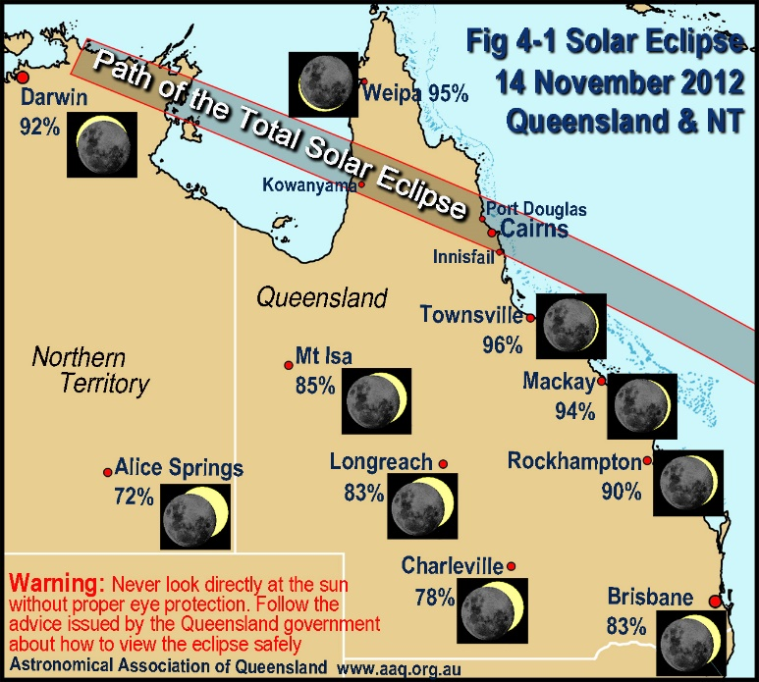
The path of totality for the eclipse of 14 November 2012 is shown in the map at right. The map also shows how the partial eclipse will appear at maximum coverage of the Sun at locations outside the path of totality. The amount of maximum coverage depends mainly on the distance of the location from the path of totality. A partial solar eclipse will occur over the whole of Australia.
The table below lists the start time of the partial eclipse, time of maximum and end of the partial eclipse as well as the maximum eclipse magnitude (the maximum percent of the Sun’s diameter covered) for locations throughout Queensland not in the path of the total solar eclipse. Times are in Australian Eastern Standard Time (UTC + 10 hours).
Location | Start | Time of | Magnitude | End | Sun
 | Partial | max eclipse | (max cover of | Partial | Elevation
 | h:m (am) | h:m (am) | Sun’ diameter) | h:m am | (at max)
 | 1st contact |  | (%) | 4th contact | (º)
Brisbane | 5:56 | 6:54 | 83 | 7:59 | 26
Bundaberg | 5:53 | 6:51 | 89 | 7:55 | 24
Charleville | 5:56 | 6:51 | 78 | 7:51 | 19
Charters Towers | 5:48 | 6:43 | 94 | 7:44 | 16
Cooktown | 5:44 | 6:38 | 99 | 7:38 | 13
Coolangatta | 5:57 | 6:56 | 82 | 8:00 | 27
Dalby | 5:56 | 6:53 | 82 | 7:57 | 24
Gladstone | 5:51 | 6:49 | 90 | 7:53 | 23
Gympie | 5:55 | 6:52 | 86 | 7:57 | 25
Ipswich | 5:57 | 6:54 | 83 | 7:59 | 26
Longreach | 5:52 | 6:47 | 83 | 7:46 | 16
Mackay | 5:48 | 6:45 | 94 | 7:48 | 19
Maryborough | 5:54 | 6:52 | 88 | 7:56 | 25
Mount Isa | 5:51* | 6:43 | 85 | 7:41 | 10
Noosa | 5:55 | 6:53 | 86 | 7:58 | 26
Rockhampton | 5:51 | 6:48 | 90 | 7:52 | 22
Roma | 5:56 | 6:52 | 81 | 7:53 | 22
Toowoomba | 5:57 | 6:54 | 82 | 7:58 | 25
Townsville | 5:47 | 6:42 | 96 | 7:44 | 16
Tully | 5:46 | 6:41 | 99 | 7:42 | 15
Weipa | 5:42* | 6:35 | 95 | 7:34 | 08
Partial eclipse timing – locations in Queensland (* = before sunrise)

If your location is not listed in the above table download and follow Activity 08 downloaded from http://www.eclipse.aaq.org.au/index.php/classroom-activities to find the timing of the eclipse from your location, as well as eclipse magnitude and elevation of the Sun.
To investigate the appearance of the eclipse follow Activity 07 on the resources CD or downloaded from http://www.eclipse.aaq.org.au/index.php/classroom-activities to investigate the appearance of the eclipse using simulation software.

Partial Eclipse in Queensland on 10 May 2013
There will be another partial eclipse in Queensland on 10 May 2013. There are some details in section 10 of the teacher information booklet, downloadable from the website. That eclipse will also occur in the morning and you can use Activity 08 to find timing and other details of that eclipse.

Safe viewing information
It is absolutely essential that safe viewing techniques be used to view the partial phases of a solar eclipse. The Queensland Government has issued advice as to how to view the eclipse safely.
This can be found at: http://www.fairtrading.qld.gov.au/safe-viewing-of-astronomical-events.htm
Information can also be found in Section 5 of the teacher booklet.
This Queensland Government advice is consistent with the advice issued by other reputable sources. This includes on the NASA safe eclipse viewing web page http://eclipse.gsfc.nasa.gov/SEhelp/safety2.html and the factsheet on the eclipse provided by the Astronomical Society of Australia at:
http://astronomy.swin.edu.au/~smaddiso/download/factsheet_23rev2x.pdf
Observing with eclipse glasses
Eclipse glasses that comply with the standards as advised by the Queensland Government and are used as advised in the government recommendations and the instructions printed on the glasses are an ideal way to observe the progress of the eclipse. However children should be clearly instructed on their use and young children should not use eclipse glasses unsupervised due to the temptation to peek at the eclipse around the glasses. It is essential that adults ensure that eclipse glasses are used properly by children and are not treated as toys.
Observing using projection
Indirect observation by pinhole projection is another safe way of observing the partial phases of the eclipse. It is particularly useful if eclipse glasses are not available. It is also useful for students to construct such a device as it will help to give them an understanding of how and why they work. Simple pinhole projectors are very easy to make and ideally every student should have one for the eclipse so that they will be able to observe the progress of the eclipse without being tempted to view the Sun directly.
There are instructions on how to make pinhole projectors from very simple easy to make versions to ones that are more sophisticated in Activity 10 Construct a pinhole projection device. For older classes you may like to set up telescope or binocular projection. See Activity 11 Indirect viewing of the Sun using a telescope or Binoculars.

What to Observe during a Partial Eclipse
Observe the timing and appearance of the eclipse
Students can practice scientific investigation, observation and understanding by firstly researching the timing, circumstances and appearance of the partial phases of the eclipse for their location, (see paragraph 1 above for details) then observing and documenting their observations to compare their observations with predictions.
Recorded details should include start of the partial eclipse (first contact), end of the partial eclipse (fourth contact), estimate of the time of maximum eclipse and percentage of the Sun’s diameter covered by the Moon.
Progress of the eclipse - Crescent shape of the Sun
At the start of the eclipse the Moon will start to cover the Sun. This will firstly appear as though there is a small bite taken out of the Sun. Coverage by the Moon will progress with the Sun taking on a crescent shape. The crescent will continue to thin until maximum eclipse, after which the Moon will then continue on to uncover the Sun.
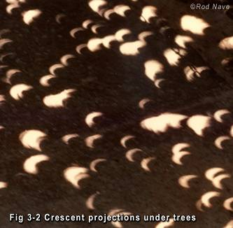
The progress of the eclipse can be observed using eclipse glasses or by indirect viewing using projection methods.
The crescent shape of the Sun can also be seen projected under trees on the ground or onto adjacent walls, as the gaps between leaves act as pinhole projectors. See the photo at right. You are much more likely to see this on walls beside trees because the Sun will be low in the sky. Interesting crescent shapes can also be seen using items with one or more holes in them such as a kitchen colander, a cheese grater or a loosely woven straw hat. Or just simply hold the fingers of one hand on top of and at right angles to the fingers of the other hand making small gaps between the crossed fingers to make a series of holes to project crescent images on the ground.
Students can make up a special sign for the eclipse with words made of holes punched in a card or piece of paper. This will spell out the word in a series of crescents. Spell out your name in this way and perhaps add the words “Eclipse 2012”. A photo of these crescent shapes (perhaps projected onto the person’s shirt) will make a wonderful memento of your observation of the event.
Sharp and fuzzy shadows
Shadows become unnatural as the crescent Sun becomes thin, being very sharp in one direction and blurry at right angles. This is due to the long thin shape of the crescent Sun. This is easy to see by observing the shadow of both hands with the fingers on one hand orientated at right angles to the fingers on the other hand and both rotated to gain the maximum effect.
Temperature
During a normal morning the temperature will increase after sunrise as the Sun warms the land. On the morning of the eclipse, the Sun will be progressively hidden, so it will not be able to provide as much heat, and consequently the temperature will not rise as much as on other mornings. If your location is close to the path of totality then the temperature may dip as the eclipse approaches maximum. Students can take temperature readings every five or ten minutes, plot these on a graph and then compare the result to the temperature rise on a normal morning.
Sky brightness and the Moon’s shadow
During a partial solar eclipse the light level will drop to an extent dependent on the maximum magnitude of the eclipse. Because our eyes are very good at compensating for varying light levels, this will often go unnoticed until the Sun is reduced to a very thin crescent. Students can note when they noticed that the light level was dimmed and estimate the degree of dimming when the eclipse is at maximum.
If your location is close to the path of totality, look in the direction of the path and you may see the Moon’s shadow moving along the path. The closer to the path, the more dramatic will be the effect. The overall sky will be quite dark at that time. If watching the Sun using eclipse glasses, the Moon will appear to cover the Sun almost completely being reduced to a very thin crescent indeed, and this crescent will appear to rotate quite quickly as the eclipse passes the maximum.
The sky will appear to be an unusual colour. Students should report on what colours they experience.
Shadow Bands
If you are in the path of totality, shadow bands can often be seen moving across the landscape for a minute or two before totality begins and for a similar time after it ends. Shadow bands appear as moving bands of light and dark and occur when regions of the Earth’s upper atmosphere bend the final sliver of light from the thin crescent Sun. If your location is within about 100 km of the path of totality you may see shadow bands. To give yourself the best chances of seeing shadow bands, look on a light coloured surface. A light coloured wall that the Sun is shining directly on would be a good surface to watch.
Biological Effects
Total solar eclipses can have some very interesting effects on animals, birds and insects. If you are close to the path of totality, and the sky goes quite dark you may be able to observe some of these effects. Examples of some things to look out for include:
- Do birds behave as if it was sunset by returning to roost or by other gathering activities or a change in their communications or song patterns?
- Do cows and other farm animals return to their night resting places?
- Do bees and other insects behave in an unusual way?
- Is there any activity of nocturnal animals, birds and insects?
- Are any changes in plants and flowers? (eg are sunflowers affected)
Observation report form
A suggested observation report form for students to complete is on the next page. Use this or copy and modify to suit.
Queensland Observations
The Astronomical Association of Queensland will be collecting student and school observations to provide an overall picture of the results of eclipse observations across Queensland. A form is provided for this purpose. Ideally this will be completed by the teacher or class in a class session after the eclipse with the information provided being representative of the class collective experience. Scan and email the completed form to eclipse@aaq.org.au . If scanning is not practicable, copy the text and responses into an email and send to the same address. The results will be posted on the website www.eclipse.aaq.org.au about two weeks after the eclipse. No school or student will be individually identified in the published results. This is an opportunity for students to participate in a Queensland wide study of eclipse effects and contribute to scientifically useful information.
STUDENT ECLIPSE OBSERVATION REPORT Date ……………………
Name: ………………………………...…. Observing Location ………………………….
INSTRUCTIONS: Complete this form as soon as possible after the eclipse and bring it to the school for a class discussion on the eclipse. Note what eclipse effects you observed and describe how they appeared.
OBSERVE THE ECLIPSE SAFELY: Never look directly at the Sun during a partial solar eclipse as you may cause serious damage to your eyesight that can never be repaired. Use only eclipse glasses as recommended by the Queensland Government or observe the eclipse indirectly using projection methods.
Observation method
- What safe observation method did you use? …………………………………………….
(eclipse glasses, projection or other – if other please describe)
Weather Conditions
- Was the weather clear or cloudy and how well could you see the eclipse?………………………….
………………………………………………………………………………………………………………..
Eclipse Times
- Record the times of the eclipse as you observed them:
Start of the partial eclipse (the Moon first started to cover the Sun): ………….
Time of maximum eclipse (when the Moon was covering the Sun the most): ……….
End of the partial eclipse (the Moon last touched the Sun) ……..
- Write here how hard or easy it was to record these times: ………………………………………………
……………………………………………………………………………………………………………………
- Estimate the maximum coverage of the Sun’s diameter by the Moon (fraction or percent): ……..
- Draw a sketch of what the Sun looked like
Just after the eclipse started:
When it was at maximum:
Just before the eclipse finished:

after start maximum near end
Partial eclipse effects
For each of these effects identify if you observed it and describe how well you observed them (e.g., not seen, barely seen, seen well or dramatic view, etc)
Eclipse Effect Did you Describe what it looked like and
observe it? how well you saw it
- Crescent shape of the sun ……. ………………………………………………………………..
- Crescents under trees ……. ………………………………………………………………..
- Darkening & colour of the sky……. ………………………………………………………………..
- Drop in temperature ……. ………………………………………………………………..
- Sharp and fuzzy shadows ……. ………………………………………………………………..
- Shadow Bands ……. ………………………………………………………………..
- Moon’s shadow ……. ………………………………………………………………..
- Unusual animal behaviour ……. ………………………………………………………………..
REPORT TO THE ASTRONOMICAL ASSOCIATION OF QUEENSLAND
The Astronomical Association of Queensland (AAQ) is collecting observational reports of the eclipse. Reports of the collective observations by the class compiled by the teacher or the class are preferred. AAQ is also happy to receive individual reports by students. Please send completed report forms to eclipse@aaq.org.au either by scanning the page and sending that or copying and pasting the report form plus responses into the email. Summary results will be published on the eclipse website www.Eclipse.aaq.org.au after the eclipse. These reports will provide scientifically useful information.
School: ………………………………...…. Latitude/Longitude if known ……………….……………….
INSTRUCTIONS: This form is to be completed as the collected observations of the class. Note what eclipse effects were generally observed and describe how they generally appeared.
OBSERVE THE ECLIPSE SAFELY: Never look directly at the Sun during a partial solar eclipse as you may cause serious damage to your eyesight that can never be repaired. Use only eclipse glasses as recommended by the Queensland Government or observe the eclipse indirectly using projection methods.
Observation method
- What safe observation methods were used? ……………………………………………………….……….
(eclipse glasses, projection or other – if other please describe)
Weather Conditions
- Was the weather clear or cloudy and how well could you see the eclipse?………………………….
………………………………………………………………………………………………………………..
- Estimate the maximum coverage of the Sun’s diameter by the Moon (fraction or percent): ……..
Partial eclipse effects
For each of these effects identify if you observed it and describe how well you observed them (e.g., not seen, barely seen, seen well or dramatic view etc)
Eclipse Effect Did you Describe what it looked like and
observe it? how well you saw it
- Crescent shape of the sun ……. ………………………………………………………………..
- Crescents under trees ……. ………………………………………………………………..
- Darkening of the sky ……. ………………………………………………………………..
(How dark did it get and in which direction and was it an unusual colour)
- Drop in temperature ……. ………………………………………………………………..
(Include any temperature recordings for eclipse start, eclipse maximum, and eclipse end)
- Sharp and fuzzy shadows ……. ………………………………………………………………..
- Shadow Bands ……. ………………………………………………………………..
- Moon’s shadow ……. ………………………………………………………………..
- Unusual animal behaviour ……. ………………………………………………………………...

