ACTIVITY 21 – 2013 Annular Eclipse in
Queensland – A simulation program.
Year Level: Years 3 to 12 (typically 8 to 18 years of age).

Background: This activity will allow students to investigate the annular eclipse of the 10 May 2013 and the partial eclipse that will occur across Queensland at the same time. This activity should only be completed after students have done Activity 04 which is a tutorial to learn the basics of the program Stellarium version 0.11.0. Stellarium is a free software program that is available from the internet at the following site : http://www.stellarium.org/ . It is recommended that the Activity 07 on the total eclipse in November 2012 also be completed first.
Aim: To determine the changes in the appearance of the Sun during an annular eclipse using the sky simulation program Stellarium and determine the effect of viewing from different locations inside and outside the path of annularity.
References:
- Sections 2.2, 3.3 and 10 of the AAQ/STAQ teacher booklet.
- PowerPoint presentation PP10 Annular Eclipse 10 May 2013.
- Activity 04 Stellarium Tutorial; Activity 07 2012 Solar Eclipse Simulation.

Safe Observing Message:
When discussing a solar eclipse, students should be reminded that it is not safe to look directly at the Sun at any time and that safe viewing methods must be used to observe a solar eclipse.
Shape of the Australian Curriculum: Science strands on focus areas.

Content descriptors: Year 3, 5, 7 and 10.
Science Understanding | Science as a Human Endeavour | Science Inquiry Skills
Yr 3  Earth’s rotation on its axis causes regular changes, including night and day (ACSSU048) | Yr 3  Science involves making predictions and describing patterns and relationships (ACSHE050) | Yr3  With guidance, identify questions in familiar contexts that can be investigated scientifically and predict what might happen based on prior knowledge (ACSIS053)
Yr 5  The Earth is part of a system of planets orbiting around a star (the sun) (ACSSU078) | Yr 5  Science involves testing predictions by gathering data and using evidence to develop explanations of events and phenomena (ACSHE081)  Important contributions to the advancement of science have been made by people from a range of cultures (ACSHE082) | Yr 5  With guidance, pose questions to clarify practical problems or inform a scientific investigation, and predict what the findings of an investigation might be (ACSIS231)
Yr 7  Predictable phenomena on Earth, including seasons and eclipses, are caused by the relative positions of the sun, Earth and the moon (ACSSU115) | Yr 7  Scientific knowledge changes as new evidence becomes available, and some scientific discoveries have significantly changed people’s understanding of the world (ACSHE119) | Yr 7  Identify questions and problems that can be investigated scientifically and make predictions based on scientific knowledge (ACSIS124)  Collaboratively and individually plan and conduct a range of investigation types, including fieldwork and experiments, ensuring safety and ethical guidelines are followed (ACSIS125)
Yr 10  The universe contains features including galaxies, stars and solar systems and the Big Bang theory can be used to explain the origin the universe (ACSSU188) | Yr 10  Scientific understanding, including models and theories, are contestable and are refined over time through a process of review by the scientific community (ACSHE191)  Advances in scientific understanding often rely on developments in technology and technological advances are often linked to scientific discoveries (ACSHE192)  People can use scientific knowledge to evaluate whether they should accept claims, explanations or predictions (ACSHE194) | Yr 10  Plan, select and use appropriate investigation methods, including field work and laboratory experimentation, to collect reliable data; assess risk and address ethical issues associated with these methods (ACSIS199)  Select and use appropriate equipment, including digital technologies, to systematically and accurately collect and record data (ACSIS200)  Use knowledge of scientific concepts to draw conclusions that are consistent with evidence (ACSIS204)  Communicate scientific ideas and information for a particular purpose, including constructing evidence-based arguments and using appropriate scientific language, conventions and representations (ACSIS208)

Copyright:
This document has been produced by members of the Astronomical Association of Queensland (AAQ) and the Science Teachers Association of Queensland (STAQ). AAQ and STAQ retain copyright of the document. The material in the document may be freely reproduced provided that it is used for non-commercial purposes and the source is acknowledged. Address any request for use of the material for commercial purposes to eclipse@aaq.org.au.
Accuracy of predictions using Stellarium
An eclipse is a wonderful demonstration of our understanding of the motions of celestial bodies and our ability to calculate with great precision exactly when and where an eclipse will occur.
Stellarium is simulation program that provides a very good demonstration of what celestial events will look like and provides reasonably accurate timing. However in order to provide reasonable speed in its calculation and display, Stellarium cannot provide precise timing for eclipses. In most cases the timing provided by Stellarium for example, the time of the start and end of the total or annular part of an eclipse for any particular location will only be accurate to within about two minutes. While in most cases these results are just fine for comparative purposes and for general observing, they should not be used for prediction of events where timing is critical for example, the start time of the total or annular part of an eclipse.
There are available methods of finding more accurate eclipse timing. One of these is the NASA eclipse website. There is another using Google Earth. These methods can provide eclipse timing which is accurate to about a second. These methods are described in Activity AT08.

THE 2013 Annular ECLIPSE ACTIVITY

The image below is designed to assist students during the completion of this Activity however students MUST HAVE COMPLETED ACTIVITY 04 before attempting this activity. It is recommended that Activity 07 also first be completed.

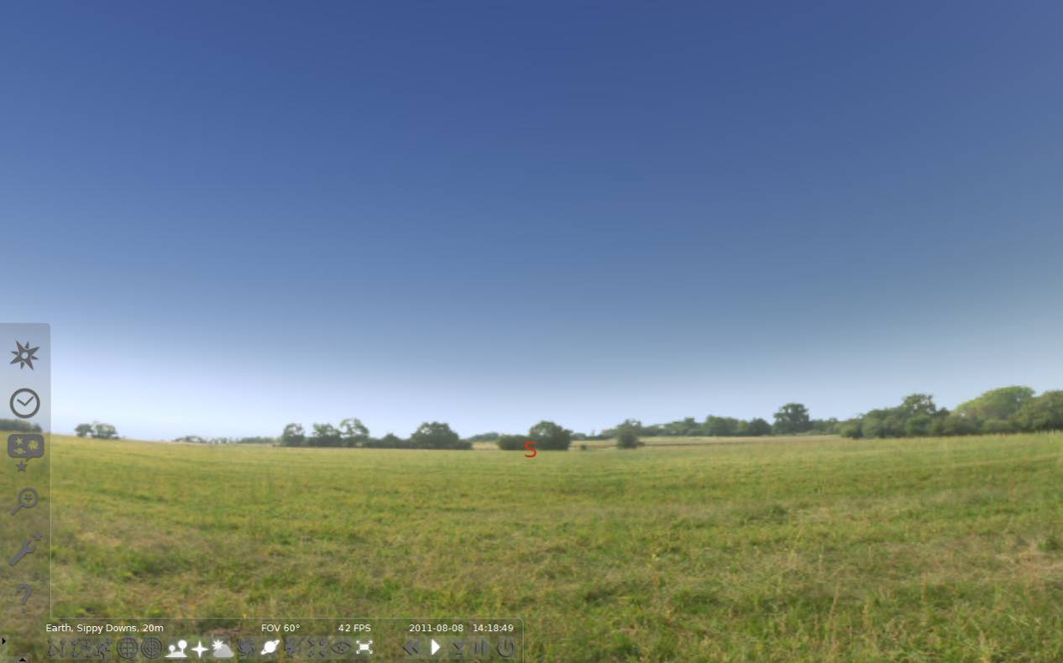
*F
*G
*DD
*E
*C
*B
*AA

Open the location window by clicking on the compass rose on the left pop up tool bar (*A). Set the Latitude to 15° 29’ 00” S and Longitude to 141° 45’ 00” E. This location is Kowanyama on Cape York Peninsular. Check on the map to see that the red arrow is pointing to Cape York Peninsular. Type Kowanyama in the Name/City box and click on Add to List. This will save the location if you want to use it later. Close the location window by clicking on the X.
Open the Date / Time window (*B). Change the date to 10 May 2013 (2013 / 5 / 10) and change the time to 7:30 AM (7:30:00). Close the Date / Time window.
Click on the Search window (*/E). Type in the word SUN and press the magnifying glass. This will centre the sun. Close the Search window. Zoom in on this object (roll the mouse wheel or press page up) until the glare of the sun disappears. Can you see the start of the eclipse?

Now go forward and back in time (use the L, J and K key or the buttons at the bottom of the screen to the left of *G). Go through the full sequence of the eclipse and draw sketches of what happens to the Sun on the circles on the next page. Use the suggested times at the top of each or use your own times.
7 : 29 : 00 7 : 55: 00

8 : 20 : 00 8 : 44 : 37

8 : 46 : 35 8 : 49 : 00

9 : 35 : 00 10 : 21 : 00
- How does this eclipse look different from the eclipse on 14 November 2012?
______________________________________________________________
______________________________________________________________
______________________________________________________________
- Describe why it looks different from the eclipse of 14 November 2012
______________________________________________________________
______________________________________________________________
______________________________________________________________
- Write down the Contact times for the eclipse:
First Contact (C1) is the start of the partial phase when the Moon first contacts the Sun;
Second Contact (C2) is the start of the annular part of the eclipse when the trailing edge of the Moon enters the Sun;
Third Contact (C3) is the end of the annular part of the eclipse when the leading edge of the Moon leaves the Sun;
Fourth Contact (C4) is the end of the partial phase when the Moon last contacts the Sun.
First Contact (C1): …………………………
Second Contact (C2):…………………………
Third Contact (C3):…………………………
Fourth Contact (C4): …………………………
- Calculate and record the duration of the solar eclipse and show how you calculated this.
The duration (including the partial phases) is …………………..
The duration of annularity is …………………..
- Find out what the eclipse will be like from your location. Change the location to your town either by finding it in the list of towns or entering the latitude and longitude. Use times similar to the times used for Kowanyama and find out:
Start time of the partial phase of the eclipse: …………………….
Time of maximum eclipse: …………………….
What is the approximate maximum percent coverage of the Sun’s diameter: …………………….
Time of the end of the partial phase: …………………….
Sketch what the eclipse will look like from your location at maximum eclipse.
You must never look directly at the Sun during the eclipse or at any other time. You MUST use safe observing methods to observe an eclipse.
ADDITIONAL ACTIVITIES
- Write a description of what the eclipse will look like from your location for the class. Describe how the Moon will move across the Sun, including which direction it will move in and include the times of first contact, maximum eclipse and fourth contact. Include your sketch of what it will look like at maximum. Include a safe viewing message warning that you should never look directly at the Sun at any time and that safe viewing methods must be used to observe a solar eclipse.
- Set the location to Townsville by selecting Townsville from the list in the location window. With the date still set to 10 May find the time of maximum coverage of the Sun and draw a sketch of it noting the time. Estimate what is the maximum percentage of the diameter of the Sun covered.
Now set the location to Rockhampton and then Brisbane. For each place find the time of maximum coverage of the Sun and draw a sketch of it noting the time. Estimate what is the maximum percentage of the diameter of the Sun covered.
Investigate if there is a relationship between the distance from the path of annularity and the percentage covering of the Sun.
- Set the Latitude to 19° 26’ 25” S and Longitude to 134° 12’ 30” E. This location is Three Ways, just north of Tennant Creek in the Northern Territory. The path of the annular eclipse also passes through Three Ways.
Set the date and time the same as for Kowanyama. Investigate the timing of the annular part of the eclipse as seen from Three Ways. What do you notice about when annularity occurs? How does it compare with the time at Kowanyama? Can you explain why there is a time difference?
You can see the path of the annular eclipse on this NASA website: http://eclipse.gsfc.nasa.gov/SEsearch/SEsearchmap.php?Ecl=20130510. Explore the path of the eclipse. If you use the zoom slider to zoom in and click to grab and move the map you can click on any point and a window will appear to show you the times of the eclipse at that point. Click on Three Ways. It is at the intersection of the Highway from Darwin to Alice springs (87) and the highway from Mount Isa (66). How do the times in the window compare to the times you have found? Note that the date and time in the window are in Universal Time. You need to add 10 hours to get Queensland time.
- Leave the location set to Three Ways and set the date to 16 February 1999 (1999/2/16) and the time to 6:03 PM (18 : 3 : 0). Another annular eclipse occurred at Three Ways at this time. It is very unusual to have two eclipses at the same place with only a few years between them. Compare the apparent size of the Moon for the 1999 eclipse with the apparent size of the Moon at the 2013 eclipse. What is the explanation for this difference in size?
You can see the path for this eclipse at:
http://eclipse.gsfc.nasa.gov/SEgoogle/SEgoogle1951/SE1999Feb16Agoogle.html. How does the width of the path compare to the width of the path of the 2013 eclipse? Does the width of the path have any connection to the apparent size of the Moon?

